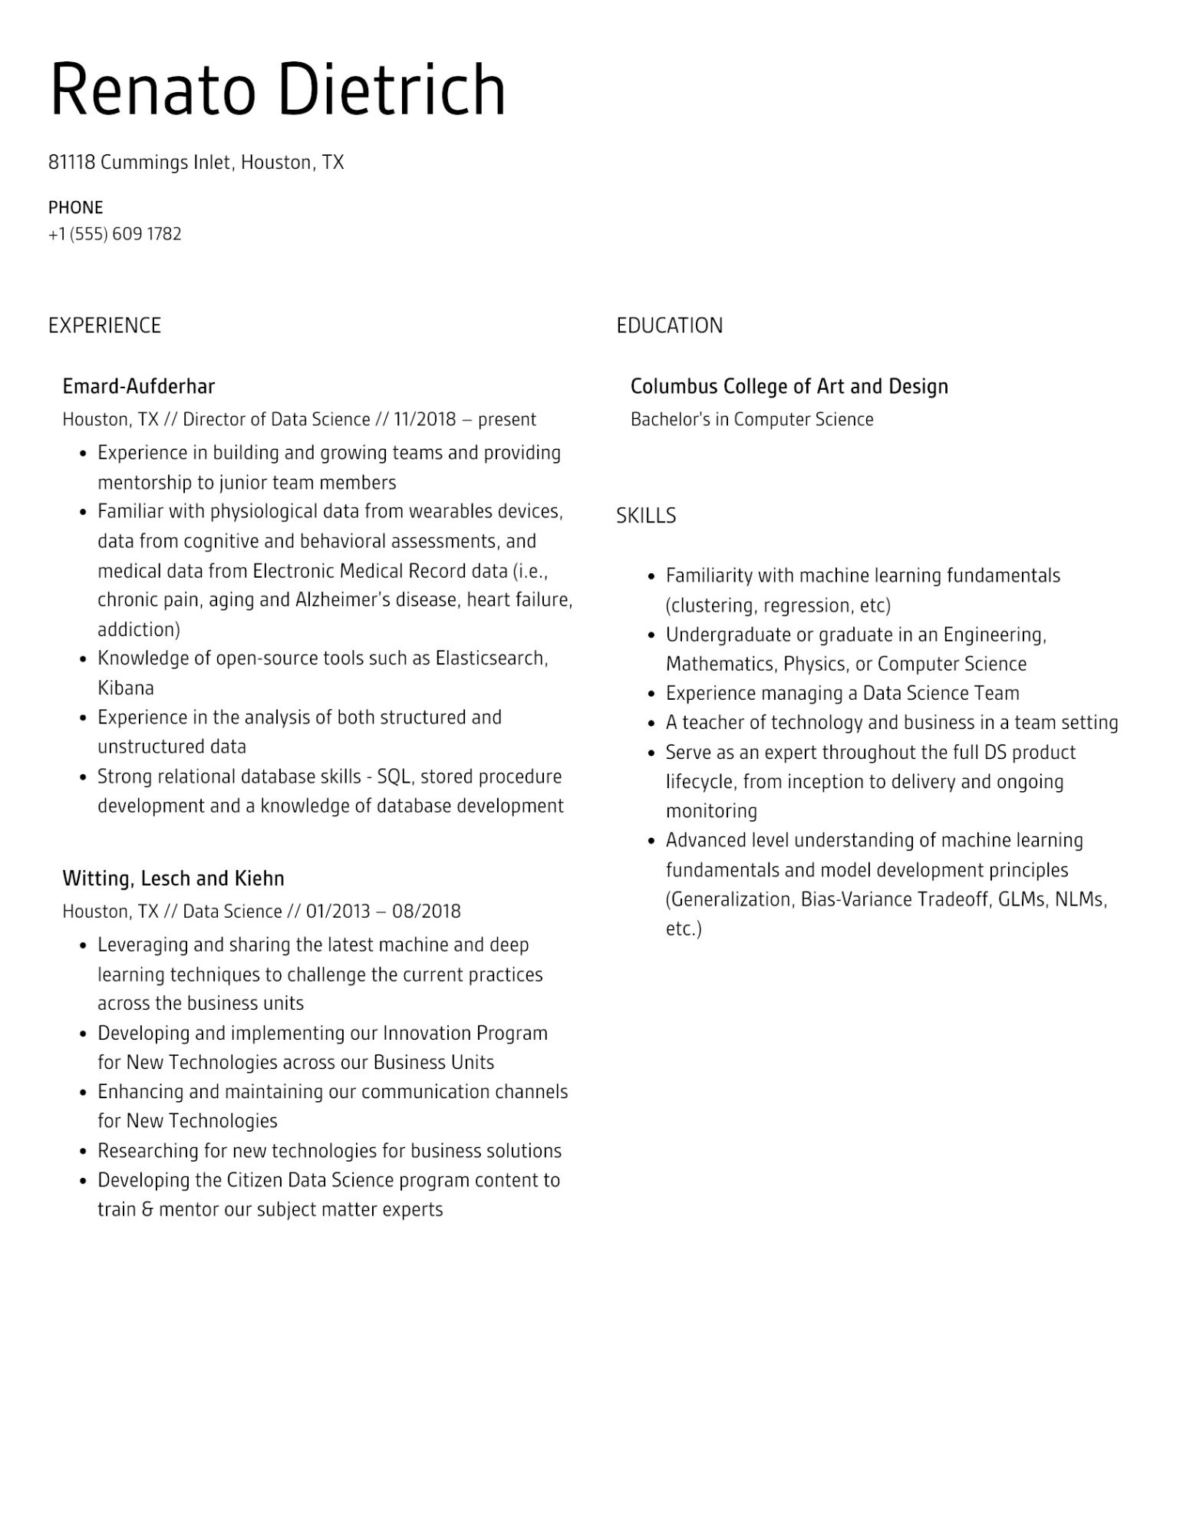
Renato Dietrich
81118 Cummings Inlet, Houston, TX
PHONE
+1 (555) 609 1782
EXPERIENCE
Emard-Aufderhar
Houston, TX // Director of Data Science // 11/2018 - present
•
Experience in building and growing teams and providing mentorship to junior team members
• Familiar with physiological data from wearables devices, data from cognitive and behavioral assessments, and medical data from Electronic Medical Record data (i.e., chronic pain, aging and Alzheimer's disease, heart failure, addiction)
•
•
•
Knowledge of open-source tools such as Elasticsearch, Kibana
Experience in the analysis of both structured and unstructured data
-
Strong relational database skills - SQL, stored procedure development and a knowledge of database development
Witting, Lesch and Kiehn
Houston, TX // Data Science // 01/2013 - 08/2018
•
·
•
•
•
Leveraging and sharing the latest machine and deep
learning techniques to challenge the current practices across the business units
Developing and implementing our Innovation Program
for New Technologies across our Business Units
Enhancing and maintaining our communication channels for New Technologies
Researching for new technologies for business solutions
Developing the Citizen Data Science program content to
train & mentor our subject matter experts
EDUCATION
Columbus College of Art and Design
Bachelor's in Computer Science
SKILLS
·
•
Familiarity with machine learning fundamentals (clustering, regression, etc)
Undergraduate or graduate in an Engineering, Mathematics, Physics, or Computer Science
Experience managing a Data Science Team
•
A teacher of technology and business in a team setting
•
• Serve as an expert throughout the full DS product
•
lifecycle, from inception to delivery and ongoing monitoring
Advanced level understanding of machine learning fundamentals and model development principles (Generalization, Bias-Variance Tradeoff, GLMs, NLMs,
etc.)

